what happens when you register a domain and we're going to use Route 53 as an example. I don't want to focus on the exact steps taken to register a domain because that differs depending on what provider you use in this lesson I want to focus on the technical steps that occur behind the scenes when you register a domain because that's what's going to be useful in the exam to answer DNS related questions and to use AWS in production.

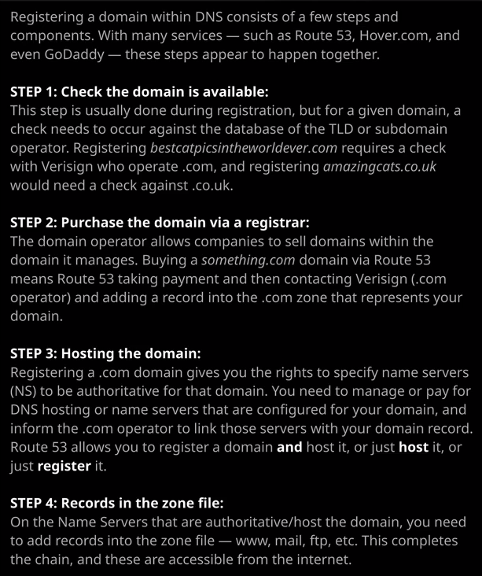

Now, the domain that I'm going to register in this lesson is one that's called associatecats.com I have already checked that it doesn't exist, but I'm going to step you through the process of doing that regardless. So the first step is to actually check the zone file for .com to make sure that there isn't already a record for associatecats.com inside that and the way we do that with Route 53 is to type associatecats.com into the search box and click Check. Now, this is no surprise associatecats.com is available. Now what I can do at this point is to click on add cart. I'll need to pick a registration period. Now these can range from one, two, three, five, or even more years, depending on the domain. So I'm going to pick one year and then hit, continue and enter my detail so I'll be the registration contact for this domain. So I'll need to enter all of my details, my name, my address, and some contact details, and these will be required to register the domain. Once I've done that, I'll hit continue and I'll need to check the contact details for the domain. Now every domain has three contact details. A registrant contact and administrative contact and a technical contact on these are stored along with the domain inside the zone that you're registering inside. So in this particular case, I'm registering associatecats.com and all this information will be stored in the domain record for that domain. These are the contacts that will be used by the operating company or any other interested party if they want to contact me about this domain. Now, you can elect to enable privacy controls so that the public don't have access to all of these details but you do need to be aware that they will be stored inside the official domain records for this domain. You also need to set whether you want to automatically renew the domain. Now, this is a Route 53 specific dialogue other providers have different methods of doing this. You'll need to select that, accept the terms and conditions, and when you're ready click on Complete Purchase. Now, at this point, we've initiated the process step two. That's on the diagram on the right of my screen. For every top level domain, the operating company has agreements with other companies that are allowed to resell those domains. Route 53 in this case is able to resell .com domains, and that's the process that we've started. So what's going to happen at this point is Route 53 are going to list this as a pending requests, so it's going to be listed in the pending request section under domains. They're going to be contacting the operating company for the .com domain and arranging for a record to be added to the zone file for that domain. So that record is going to be associatecats.com. Route 53 does offer name servers as part of this service, so it's going to create a hosted zone, which is a zone record for associatecats.com. Allocate a number of name servers, provide those names servers to the operating company for the .com domain and once they've done that, the domain will be available for use. Now it's going to take a number of minutes anywhere up to a number of hours to actually get this process completed end to end and so we need to wait for that to complete but once it has completed, the domain will vanish from pending domains and move into registered domain. So that means the domain is fully registered. If I open up associatecats.com, I'll be able to see the actual registered record for the domain, so you'll see the three contacts, as well as the actual details that are contained inside the .com zone for this domain and the important ones are the name servers. So these are the name servers that have been added to the associatecats.com record and are now authoritative for this domain and they're the Route 53 name servers that contain the zone for this domain and so what we've basically done is integrate this domain with the global DNS platform. We've registered it. We've got it added to the .com zone, and it's been delegated through to four name servers, and these are managed by Route 53. So now, at this point, because Route 53 are hosting the zone for us because we've registered the domain because we've got added to the .com zone that means this domain is now active on the public internet, and we can go ahead and create records and interact with it and get those records pointing at services. Okay, so that's everything that I wanted to cover in this lesson. **I just wanted to give you a brief introduction to how domain registration works. What we've essentially done is initiated the registration process. Route 53 have then communicated with the operating company of the .com top level domain. We created an associatecats.com record in the zone file for that top level domain, and that's been handled by Route 53. Once that registration has been completed, Route 53 of assigned us a number of name servers. They've created a hosted zone. So a zone file that's got the records for this domain. So that's what's on screen now and then that zone file has been hosted on those name server's and those names servers has been given to the operator of the .com top level domain, and they've been delegated the authority for this domain. So these name servers are now an authority for associatecats.com. It's a simple process end to end, but it's one that's followed each and every time a domain is registered.** Now that's been a simple example of domain registration and in the next lesson, I'm going to be demonstrating the differences between public zones, which is what we've just created now so **when you register a domain it creates a public zone versus private zones, and private zones are only available inside VPCs that you select.** So I want to tell you about the differences the architectures as well as give you some scenarios when you might make use of private zones inside AWS because it's a topic that tends to feature in the exam. So go ahead and mark this video as complete and when you're ready, join me in the next.